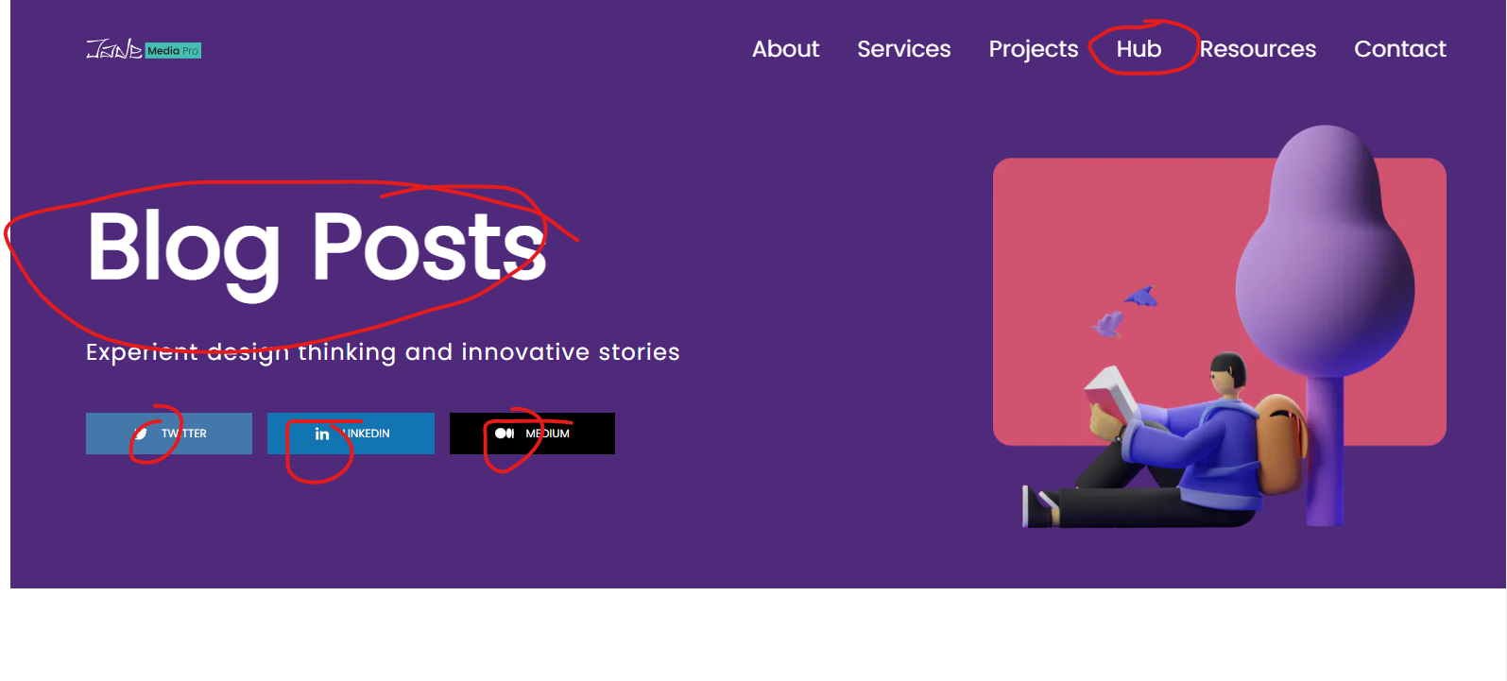

“Hub” bold effect and the line interaction.

“Blog Posts” needs to be bold like Figma.

All links available to the socials.

Original Content for 5 blog posts available.